https://fsd.tcsbank.ru/case/4208948/info
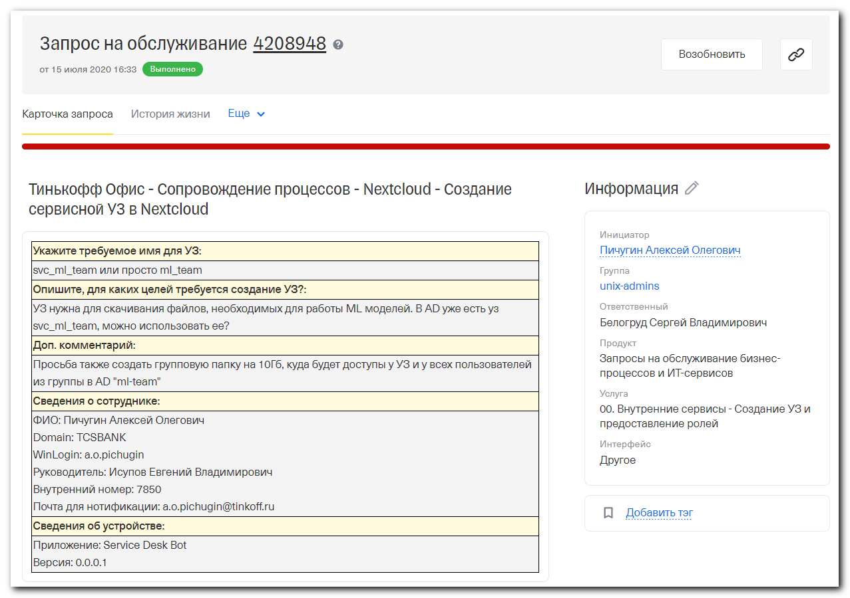
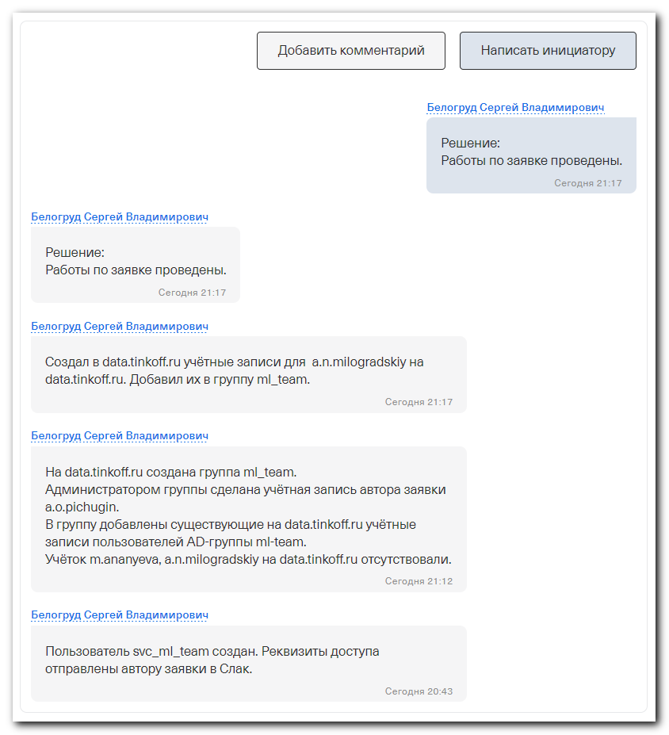

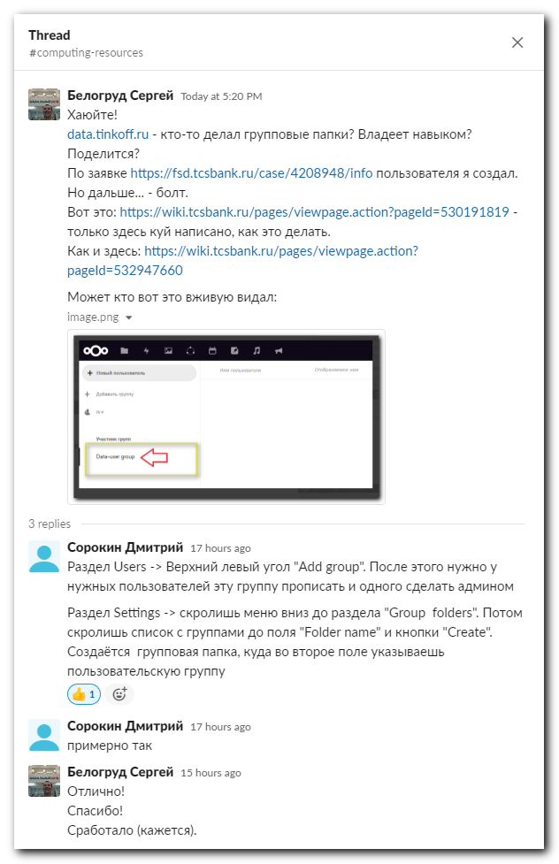

#
# The first task of this SD was about creation svc_... user. I created it.
# And I was set up password for it manually. Because this user has no its mail-box.
# The password have to contain at leas one special character. Instead it will not be accepted by data.tinkoff.ru.
# [root@centos ~]# pwgen -c -n -s -y -C 10 1
# And info about password was sent to user who opened the SD task.
#
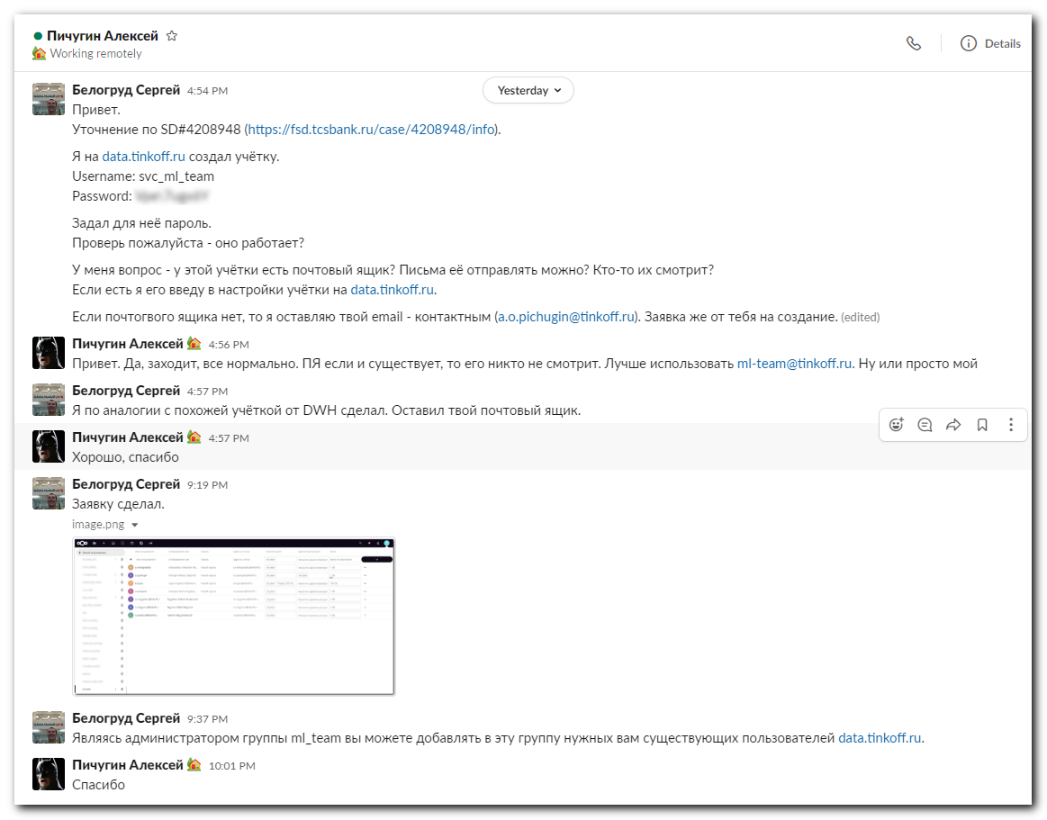
#
# Was created a group “ml_team”.
# And the user was added into tihs group as a member and as an Administrator.
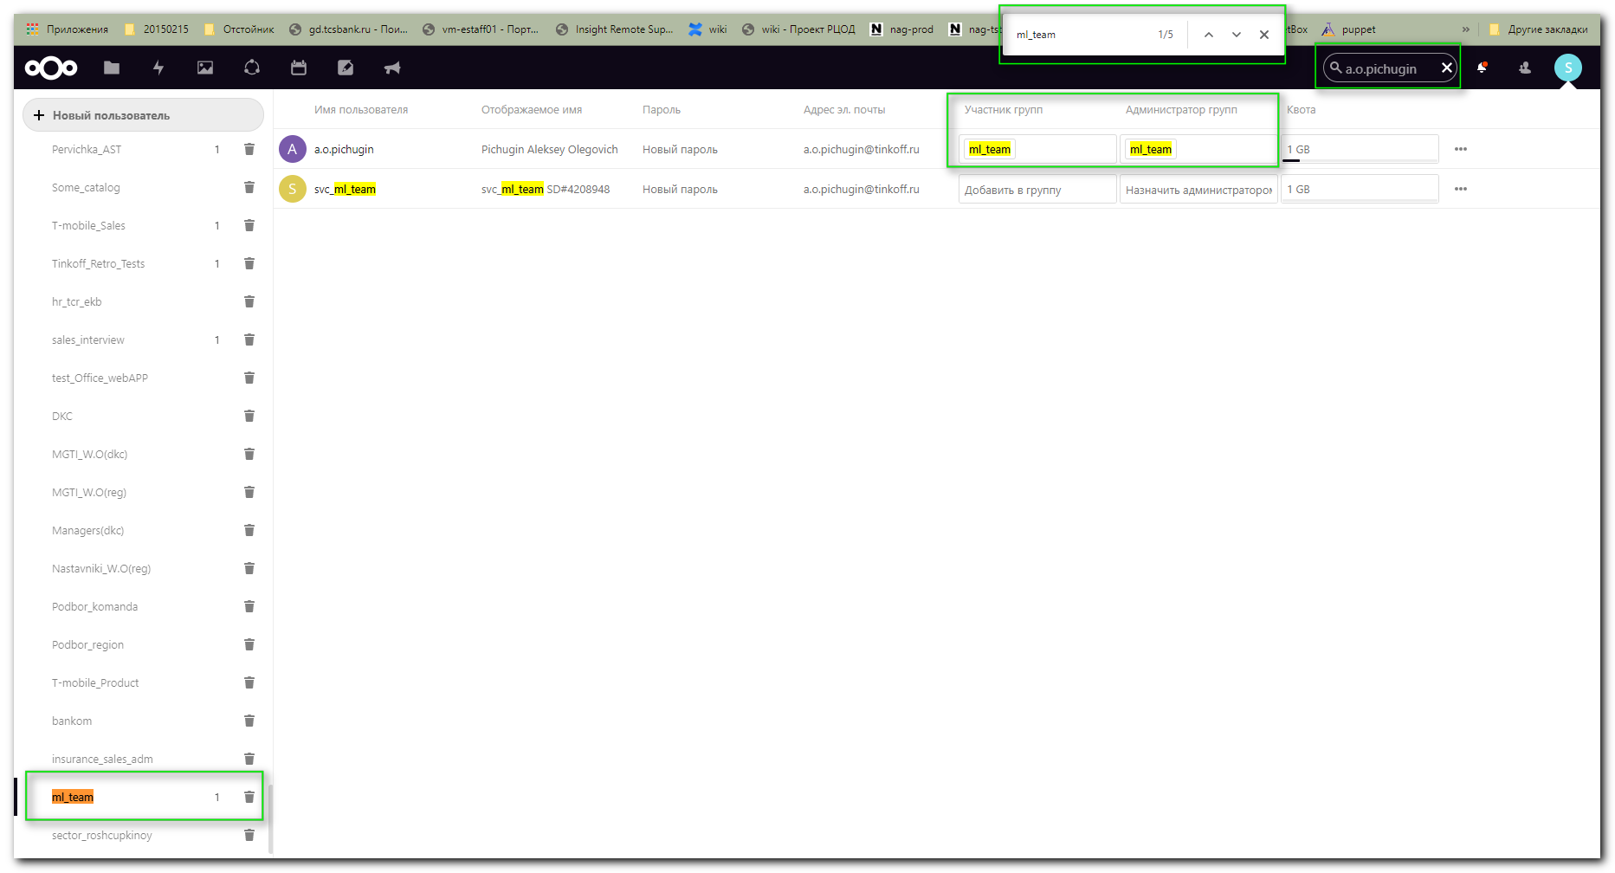

#
# Then was created a “Group folder” (https://wiki.tcsbank.ru/pages/viewpage.action?pageId=530191819).
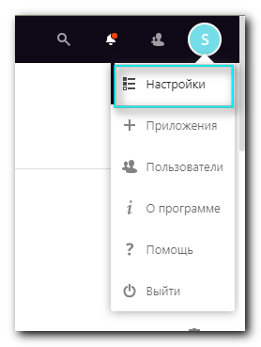
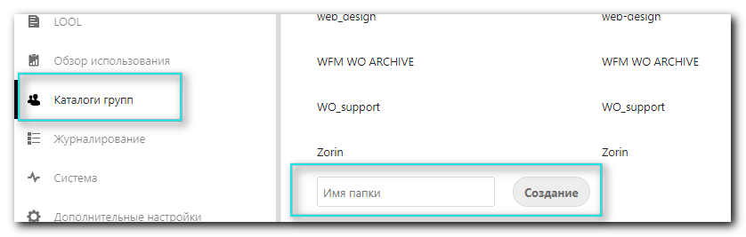

# Then for created the “Group folder” was previously created group “ml_team”.
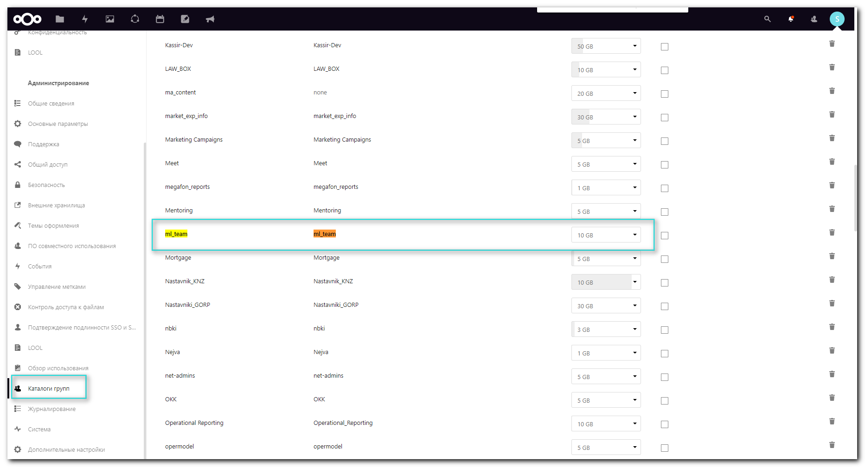

#
# Then aded into creaded group all other its members.
